Geometry: Unit 13, Lesson 5
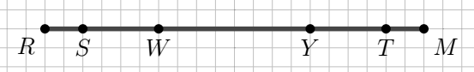
- Directed line segment $\overline{RM}$ is shown, where points $S$, $W$, $Y$, and $T$ are on the segment. What point divides directed line segment $\overline{RM}$ into a $3 :7$ ratio?

Point $W$

- What is the value of the expression $\left(\frac{5}{2}\right)2+\left(\frac{1}{2}\right)7$?

$$8.5$$

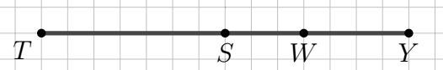
- Line segment $TY$ is shown, where points $S$ and $W$ are on the segment. Is the ratio of $TS :TY$ the same as the ratio of $SY :TY$?

Yes

